Activity 3.1: Adding an external hyperlink
Create a folder called 'Designing websites 3' and save these files to it:
- lesson3_index.html
- lesson3_style.css
Edit 'lesson3_index.html' to add a hyperlink to your favourite search engine.
The hyperlink should be included in a suitable sentence. For example:
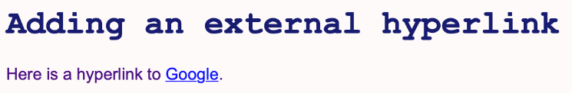
Remember, if you open your favourite search engine in a browser, you can copy its URL from the address bar at the top of the page.
Save your HTML file and then open it in a browser.
Take a screenshot of the web page and insert it here:

Click on the hyperlink to open the linked page.
Take another screenshot to show the web page that has been opened and insert it here:

